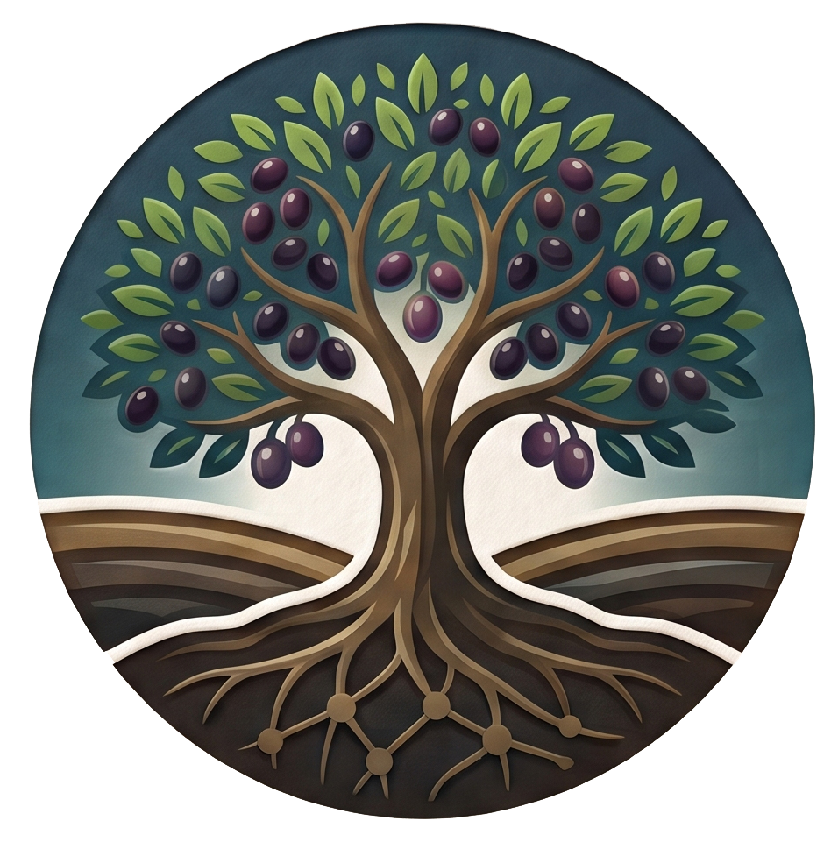
THEGOODGROUND.ORG
Matthew 13:23
WEEK ONE: What is Salvation?

Week 1 – What is Salvation?

Salvation is why we’re all in this room today. At some point in our lives, we realized there was a problem. Try as we might, there were things in our lives that we could not fix. Sin was that problem.
Sin is rebellion against God. Sin breaks our fellowship with God and leaves us spiritually lost. Sin creates a barrier between us that no human effort can remove. What is the cure?
God loves us more than we can fathom. When Jesus was asked what the greatest commandment is, He said 1) Love God; 2) Love people. He went on to say that all of the Old Testament laws (613 laws) hang on these two. When we do anything contrary to loving God and loving people, that’s sin. Sin always separates us from God, because it’s like shaking your fist in the face of the Source of your own life. We’re all guilty of this kind of rejection of God. Is there any hope of reconciliation with God?
The answer is Salvation.
Webster’s dictionary defines salvation as:
- Deliverance from the power and effects of sin.
- Preservation from destruction or failure.
- Something that saves or delivers from danger.
To understand salvation, we first have to understand what we needed to be saved from!
Romans 6:23 (NIV) For the wages of sin is death, but the gift of God is eternal life in Christ Jesus our Lord.
This single verse contains the entire story of the gospel in one sentence. The problem. The consequence. The solution. The gift. This is what Jesus did. All we have to do for our part is to believe and be a good receiver.
When today’s class is over, I want you to take away these two things:
- I want you to know that you know that you’re going to heaven. (Know 100%)
- I want you to be able to lead someone else to Jesus.
I like to ask these two questions to people when they’re not 100% sure if they’re going to heaven. You can use this when talking about Jesus to other people.
If you were to die today or if Jesus decided that today was the day that He would return and the rapture happened, do you know with 100% confidence that you would go to heaven?

Are you..
- 50% sure?
- 75% sure?
- 100% sure?
Here’s the second question: what qualifies a person to go to heaven?
- Be a good person
- Be nice to people
- Give to charity
- Go to church
- Try really hard to do all the right things
Here is what the Bible tells us and how we can know for sure whether or not we’re going to heaven.
Romans 10:9-13 (NIV) ⁹ If you declare with your mouth, “Jesus is Lord,” and believe in your heart that God raised him from the dead, you will be saved. ¹⁰ For it is with your heart that you believe and are justified, and it is with your mouth that you profess your faith and are saved. ¹¹ As Scripture says, “Anyone who believes in him will never be put to shame.” ¹² For there is no difference between Jew and Gentile—the same Lord is Lord of all and richly blesses all who call on him, ¹³ for, “Everyone who calls on the name of the Lord will be saved.”

Here’s a simple way to break this down and make it easy to remember.
A - Admit: Recognize that you are a sinner and have fallen short of God's standards (Romans 3:23 - ²³ for all have sinned and fall short of the glory of God).

B – Believe: Trust that Jesus Christ died on the cross for your sins, rose again, and is the only way to salvation (John 3:16).

C – Confess: Declare that Jesus is Lord and Savior of your life (Romans 10:9-10).

Salvation is God's gift to us. It’s not something we earn, buy, or deserve. It's Him rescuing us from sin and restoring us back into a right relationship with Him.
The problem is real. Sin has separated us from God, and there was nothing we could do on our own to fix that. No amount of good works, good living, or religion will solve the sin problem.
God sent Jesus to do what we never could. Through His death on the cross and His resurrection, Jesus guarantees the forgiveness of our sins: past, present, and future. Jesus made a way for us to be in right standing with God. That's grace, completely unearned, completely undeserved.
Salvation calls for a response from us: repentance, surrender, and genuine trust in Jesus. You receive it by faith, not by performance.
Ephesians 2:8-9 (NIV) For it is by grace you have been saved, through faith—and this is not from yourselves, it is the gift of God— 9 not by works, so that no one can boast.
No matter how good a person you try to be, it won’t be good enough. Likewise, you could give away all the money in the world, and it wouldn’t be good enough. You can go to church every single time the doors are opened and have perfect attendance, and it won’t be good enough. You can try harder and harder until you can’t try any harder, and it still won’t be good enough.
The gospel is really simple. There is only one way to get to heaven, and that is only through Jesus.
John 14:6 (NIV) Jesus answered, “I am the way and the truth and the life. No one comes to the Father except through me.

The Sin that Separates
We have to go all the way back to the very beginning of humanity to really understand. In the book of Genesis, the very first book of the Bible, we learn about Adam and Eve.
Where Sin Came From
Read Genesis Chapters 2 and 3 on your own.
God planted a good garden and gave Adam and Eve one rule: eat from anything you want, except the tree of the knowledge of good and evil. Notice the freedom! Sometimes people feel hemmed in by God’s laws, but they had the whole earth to explore – wide freedom! – with only one tree that was off limits. Why was that one tree off limits? The reason was simple. The day you eat from that tree, you will die.
The serpent, Satan, came and spoke to Adam and Eve. He questioned them, “Did God really say you can't eat from any tree in the garden?" He convinced Adam and Eve that they were somehow missing out. He convinced them they could be like God if they ate of the tree God told them not to eat.
The moment they ate, everything changed. Their first response was shame. Their second response was hiding. The God who created them and loves them was now someone they were hiding from. When God confronted them, neither one of them confessed their guilt. Adam pointed at the woman. The woman pointed at the serpent. They were playing the blame game like little children do.
The judgment was real. God removed them from Eden and put angels with a flaming sword to guard the garden. Sin didn't just make them feel bad. It separated them from God entirely.
But here's what you can't miss. Before God sent them out, God made garments of skin to cover their shame. Something had to die to clothe them. It was the sacrifice that had to be made. This is the first picture of what the entire Bible is building toward. Sin has a cost; judgment must be fulfilled. Blood has to be shed, and God Himself was always going to be the one to provide the covering.
Sin is not just doing bad things. Sin is rebellion against God. Adam and Eve rebelled against God. Sin breaks our fellowship with God and leaves us spiritually lost. Sin creates a barrier that no human effort can remove.
Imagine a perfectly clean glass of water. That water represents your life as God intended it to be, pure and without defect. Now imagine putting just one drop of bitter black ink into it. The whole glass becomes contaminated; even though it was only a small drop, the water is no longer clear; it’s black. Anyone can see the contamination. Anyone can taste the contamination.
That’s what sin is like. It only took one act of disobedience to affect everything.

2. We All Need a Savior
The Bible's answer is clear: you cannot save yourself. The gap between sin and holiness is not something that human effort can ever fix.
Ephesians 2:1-3 (NIV) As for you, you were dead in your transgressions and sins, ² in which you used to live when you followed the ways of this world and of the ruler of the kingdom of the air, the spirit who is now at work in those who are disobedient. ³ All of us also lived among them at one time, gratifying the cravings of our flesh and following its desires and thoughts. Like the rest, we were by nature deserving of wrath.
Paul uses the language of death. Not sickness, death. A sick person might recover with the right medicine or with enough time and rest. A dead person cannot do anything to help themselves. That is the image Paul chooses for the human condition apart from God: not sick or wounded, but spiritually dead. This is why we cannot save ourselves. A dead person, as hard as they might try, cannot generate life. Life has to come from the Source of Life, the One who gave it to us in the first place.

A. No One is Good
Think about the most disciplined, morally upright, genuinely good person you know. They still lie sometimes. They still sometimes think about themselves first. They sometimes carry grudges longer than they should. They still have private thoughts they would be ashamed of if everyone could see them. It’s like the one drop of contaminated ink in the glass of water.
Isaiah 64:6 (NIV) All of us have become like one who is unclean, and all our righteous acts are like filthy rags; we all shrivel up like a leaf, and like the wind our sins sweep us away.
Romans 3:23 (NIV) ²³ for all have sinned and fall short of the glory of God,

Isaiah is not saying that good deeds are worthless. He is saying that when measured against God's holiness and placed before Him, even our best efforts fall so incredibly short. Isaiah is saying our righteousness is like used toilet paper compared to God.

B. The Issue of Justice
Here is something that makes salvation both necessary and costly: God is not only loving but also perfectly just. And justice requires judgment of sin. It can’t be ignored. It can’t be excused. God cannot simply overlook it because He is good.
Think about it this way. Imagine a judge who lets every criminal go free regardless of what they have done, simply because he feels like he should give mercy to everyone. We would not call that judge a good judge; we would call him corrupt. He would probably face jail time himself. Real justice requires that wrongs be dealt with, that crime has consequences, and that the standard of what is right actually means something. God's holiness demands the same. Sin has a cost. The cost is judgment. Judgment requires a sacrifice. Here’s the issue, though: we are not enough to be the sacrifice, and God never called us to be. We could never pay this debt through any means. Jesus is the sacrifice that takes our place. There is no other way to pay the price. (Read the Parable of the Unforgiving Debtor, Matthew 18:21-35)
So here is the problem: God loves humanity deeply and wants a relationship with us. But His justice demands that sin be punished. His holiness means that He cannot simply pretend we’ve never done any evil, just like he can’t pretend that we’ve never had any evil done to us.

C. Only God Can Fix This Problem
John 3:16-17 (NIV) ¹⁶ "For God so loved the world that he gave his one and only Son, that whoever believes in him shall not perish but have eternal life.
¹⁷ For God did not send his Son into the world to condemn the world, but to save the world through him."
Salvation belongs entirely to God. He did not wait for humanity to figure it out. He did not stand at a distance, hoping we would eventually reach Him. He came to our rescue. He removed the gap. "God so loved the world that He gave." Salvation begins with His love and His action, not ours.

3. The Power of the Cross

We must understand the profound meaning of the cross. It’s so much more than a piece of jewelry or something you see in a church. The cross is THE defining moment in history where God poured out his love and His wrath. The cross solved the problem of sin and made a way for God to forgive sinners once and for all.
To understand what happened at the cross, you need one key concept: substitution. Jesus did not die because He had done anything wrong. He had lived a perfect life, the only human being in history to do so. He died in our place, as our substitute. He paid the penalty for our sin, so that we would not have to pay it ourselves. We need to remember that you and I belonged on that cross.
2 Corinthians 5:21 (NIV) God made him who had no sin to be sin for us, so that in him we might become the righteousness of God.
Let’s read that scripture again. God made Him who had no sin to be sin for us, Jesus, the only perfectly innocent person who ever lived, to take our place. He took on everything we deserved. So that in Him we might become the righteousness of God. He took our sin, and in exchange, we receive His righteousness.

A. What the Cross Accomplished
Propitiation - The wrath of God was satisfied.
1 John 2:2 (NIV) ² He is the atoning sacrifice for our sins, and not only for ours but also for the sins of the whole world.
Propitiation means that the penalty for sin, the wrath that God's holiness demands, was fully paid for by Jesus on the cross. God's justice was not ignored. It was completely satisfied. In Jesus, God both condemned sin and forgave the sinner at the same time.
Redemption - We were purchased and set free.
Ephesians 1:7 (NIV) ⁷ In him we have redemption through his blood, the forgiveness of sins, in accordance with the riches of God’s grace.
Redemption is to pay the price for an enslaved person’s freedom. We were slaves to sin, unable to free ourselves, and Jesus paid the price to buy us back and set us free.
Reconciliation - The broken relationship was restored.
Romans 5:10 (NIV) ¹⁰ For if, while we were God’s enemies, we were reconciled to him through the death of his Son, how much more, having been reconciled, shall we be saved through his life!
Reconciliation is about relationship. Two people who were separated and had become enemies are brought back into a right and good relationship. The cross is not just a legal transaction. It is the restoration of the relationship between God and humanity that sin had destroyed.
Justification: We were found not guilty.
Romans 5:1 (NIV) Therefore, since we have been justified through faith, we have peace with God through our Lord Jesus Christ.
Justification is like when a judge declares the final verdict in a court. In the courtroom of heaven, the charges of sin against you are real. You are guilty of sin. But because Jesus took the punishment in your place, the judge can declare you "not guilty" without compromising justice. The debt has been paid. The verdict is clear. You are justified and declared righteous, not because you earned it, but because Jesus paid for it.
Cleansing – We no longer feel guilty.
Hebrews 9:14 (NIV) How much more, then, will the blood of Christ, who through the eternal Spirit offered himself unblemished to God, cleanse our consciences from acts that lead to death, so that we may serve the living God!
This cleansing is represented by water baptism. In the same way that taking a shower or bath cleanses your body, accepting Jesus’s sacrifice cleanses our conscience, so we no longer feel guilt and shame about what God Himself has cleaned up!
2 Corinthians 5:17 (NIV) ¹⁷ Therefore, if anyone is in Christ, the new creation has come:^{[a]} The old has gone, the new is here!

B. The Resurrection of Jesus Finishes it.
The death of Jesus would be a tragedy if that’s where the story ended. (His 1st century followers’ response between his death on the cross and His miraculous resurrection emphasizes this.)
Acts 2:24 (NIV) 24 But God raised him from the dead, freeing him from the agony of death, because death couldn't keep its hold on him.
The resurrection of Jesus is God's declaration that the payment was accepted. Death could not hold the one who had no sin of His own. When Jesus walked out of the tomb on the third day, He announced that sin and death had been defeated. The resurrection is the proof that the cross worked.

4. You Can’t Buy Grace

Our human mind defaults to "I have to earn it." We keep score. We think if we do enough good things, if we go to church enough, if we clean up our act enough, eventually God will owe us something. That's not grace. That's a transaction. And God is not in the transaction business.
Grace says it's already been done, not almost done or pending your behavior. It is done!
Ephesians 2:8–9 (NIV) ⁸ For it is by grace you have been saved, through faith, and this is not from yourselves; it is the gift of God ⁹ not by works, so that no one can boast.
Romans 6:23 (NIV) “For the wages of sin is death, but the gift of God is eternal life in Christ Jesus our Lord.”
Romans 4:14, 16a (NIV) “14 For if those who depend on the law are heirs, faith means nothing and the promise is worthless... 16 Therefore, the promise comes by faith, so that it may be by grace and may be guaranteed to all Abraham’s offspring—not only to those who are of the law but also to those who have the faith of Abraham. He is the father of us all.
- You cannot earn salvation
- You cannot pay God back
- You cannot be “good enough”
Here's where it gets personal. A lot of people are exhausted trying to be good enough for God. They carry this quiet weight of feeling like they're always behind, always falling short, always one more failure away from losing whatever standing they think they've built up. That weight was never yours to carry. You were never going to be good enough, not because God cruelly set the bar too high, but because the bar was set at perfection and you are human.
Galatians 2:16 (NIV) “…a person is not justified by works of the law but through faith in Jesus Christ…”
And here is the thing about trying to earn what God freely gives. It is actually an act of pride dressed up as effort. It says, "I can handle this myself." It says, "My goodness is enough." But you cannot be godly without God. You cannot produce the fruit of a life connected to Him while refusing to be connected to Him.
Grace is not a reward for the deserving. It is a rescue for the undeserving. That is the whole point. Receive it.

5. Repentance
Salvation requires a genuine response from us: repentance.
Acts 3:19 (NIV) Repent, then, and turn to God, so that your sins may be wiped out, that times of refreshing may come from the Lord,
We need to know what repentance means. We mess up, we feel guilty, we tell God we're sorry, and we move on until the next time. That is not repentance. That is remorse. Remorse without a change of direction leaves you in the same place.
What is Repentance?
- A change of mind about sin and God
- A turning away from sin
- A turning toward God
Mark 1:15 (NIV) “The time has come,” He said. “The kingdom of God has come near. Repent and believe the good news!”
You cannot hold onto sin and follow Jesus at the same time. What do you need to turn away from?
Repentance means more than saying you’re sorry. It means turning from sin and turning to God. It is a change of heart that leads to a change of direction. It is the ongoing willingness to say, God, you are right, and I was wrong, and to keep walking in the direction of Him. That kind of repentance is not a burden. It is the door to freedom.
Fell again?
Keep short accounts! Set aside time every day to invite the Holy Spirit to convict you of sin, then agree with God and invite His help to change.
1 John 1:9 (NIV) “If we confess our sins, he is faithful and just and will forgive us our sins and purify us from all unrighteousness.”
James 4:6b (NASB) “God is opposed to the proud, but gives grace to the humble.”
Proverbs 24:16-18 (NIV) 16 For though the righteous fall seven times, they rise again, but the wicked stumble when calamity strikes.

6. You are a New Creation
2 Corinthians 5:17 (NIV) Therefore, if anyone is in Christ, the new creation has come: The old has gone, the new is here!
This is the most important point I want you to take away from today. When you invited Jesus to become your Lord and Savior, the old you is gone. You are a new creation. That doesn’t mean all your problems are gone. It doesn’t mean your bad habits disappear. It doesn’t mean you won’t still have relationships in your life that need work. And it certainly doesn’t mean you won’t face any difficulties in life. You’re going to have to choose to embrace your new identity as a follower of Christ every day.

Embracing Your New Identity
Here is what happened the moment you said yes. God didn’t just forgive you and go back to heaven. He moved in.
1 Corinthians 6:19-20 (NIV) Do you not know that your bodies are temples of the Holy Spirit, who is in you, whom you have received from God? You are not your own; 20 you were bought at a price. Therefore honor God with your bodies.
In the Old Testament, God’s presence lived in a building. There was a temple in Jerusalem, and there was a room inside it, and the presence of God rested in that room.
Then Jesus died, the curtain tore, and everything changed. The presence of God no longer lives in a building.
1 Corinthians 3:16 (NIV) Don’t you know that you yourselves are God’s temple and that God’s Spirit dwells in your midst?
We are the temple now. Not the building, God’s people. And notice Paul says it two ways, because it is true two ways. Here in chapter 3 the “you” is plural: you together are God’s temple, God’s Spirit in your midst. That is this room. Then in chapter 6 he gets personal: your body is a temple of the Holy Spirit.
The building isn’t holy. You are. And we are.
And notice the two sentences Paul builds on that. “You are not your own.” And “you were bought at a price.” That is ownership language. It is the language of a purchase that has already been completed. You didn’t rent this new life, and you didn’t earn it. Jesus bought it, and He holds the receipt.
I’m sure most of us have moved out of our parents' home and either rented an apartment or moved into a different house. When you take ownership of a new place of residence, you don’t usually acquire the things left there from the previous occupants. Before you move into that new place, the other people move out, take their things with them, and a deep cleaning happens before you arrive. However, this is not so with Jesus. He comes to live inside of you, despite any messes or things that may be in disrepair. Jesus still moves in when the carpets are dirty, when the foundation is cracked, and the roof has holes in it. Thankfully, He doesn’t let your temple stay that way. With your cooperation, He comes in, and the renovation begins.
You are God’s house. He lives in you. He determines what stays and what needs to go. He is the one who heals your brokenness and restores your life. Even when it feels like God isn’t present and “the repairs” don’t feel like they’re happening, I want to remind you that God tells us in Hebrews 13:5, He will “…Never will I leave you; never will I forsake you.”

Cleaning Out Your Actual House
In that same way that God is cleaning our temple and purging the things out of our lives that don’t belong, we need to remember to do the same thing to our actual house. Reminders and remnants from the past might still exist at home, and they will be stumbling blocks to embracing our new identities in Christ.
Colossians 3:5 (NIV) Put to death, therefore, whatever belongs to your earthly nature: sexual immorality, impurity, lust, evil desires and greed, which is idolatry.
Purge your house of anything counterfeit to God. If you’re not sure what qualifies as counterfeit, then ask the Holy Spirit. If it’s still unclear, ask one of us. Whatever that vice is, it’s a cheap copy of something real that God offers. No one has ever reached for alcohol, drugs, or porn (just some examples) because that was their first choice. They were looking for peace, or numbness, to stop feeling something. I want to encourage you to let those things go. God wants to be the one to provide your peace. He is Jehovah Shalom, which is Hebrew for the God of Peace. And don’t pass those vices on to anyone else. Throw them out. You don’t need them now; no one else will either.
If you’re struggling with this, ask for help. There is no condemnation here. The leaders of this class and the pastors in this church love you and want the very best for you. You’re not alone in your struggle. Before any of us knew Christ, we were once there too. We want you to live in the same freedom that God has given us to walk in.

Closing

Let’s ask one last question. How can anyone become godly without God??
Isn’t that the lie that the serpent, the devil, told Adam and Eve?
Genesis 3:4-5 (NIV) “You will not certainly die,” the serpent said to the woman. ⁵ “For God knows that when you eat from it your eyes will be opened, and you will be like God, knowing good and evil.”
And the enemy is still telling that lie today.
It is impossible to be godly without God.
Romans 10:9 (NIV) If you declare with your mouth, “Jesus is Lord,” and believe in your heart that God raised him from the dead, you will be saved.
Salvation is a free gift that requires a response of humility, faith, and repentance.
- Sin separates us from God
- We cannot save ourselves
- Jesus paid the price on the cross
- Salvation is a free gift
- We respond with humility, repentance and faith
Our Response
This is not just information. It is an invitation.
- Acknowledge your sin
- Trust in Jesus
- Turn from your old life
- Receive the gift of salvation

Prayer of Salvation
Remember your ABC’s
A - Admit: Recognize that you are a sinner and have fallen short of God's standards (Romans 3:23 - ²³ for all have sinned and fall short of the glory of God).
B – Believe: Trust that Jesus Christ died on the cross for your sins, rose again, and is the only way to salvation (John 3:16).
C – Confess: Declare that Jesus is Lord and Savior of your life (Romans 10:9-10).

Lord, I am a sinner. I will always fall short. I cannot save myself. I believe Jesus died for me on the cross and rose again, defeating sin and death. I repent, turn away from my sin, and put my trust in You. Be my Savior and my Lord. Be completely in charge of my life from this day forward. Amen!
Weekly Challenge:
Pray it out loud - If you have never genuinely repented and received grace, this is your week to do it. Find a quiet place, get alone with God, and say it out loud. Tell Him what you are turning away from. Tell Him you receive what Jesus did on the cross. If you’ve already made that decision, find someone this week and tell them about it.
Bonus Challenge: Talk to someone in your life about the salvation you’ve received. You may have an opportunity to lead them to receive Jesus.

