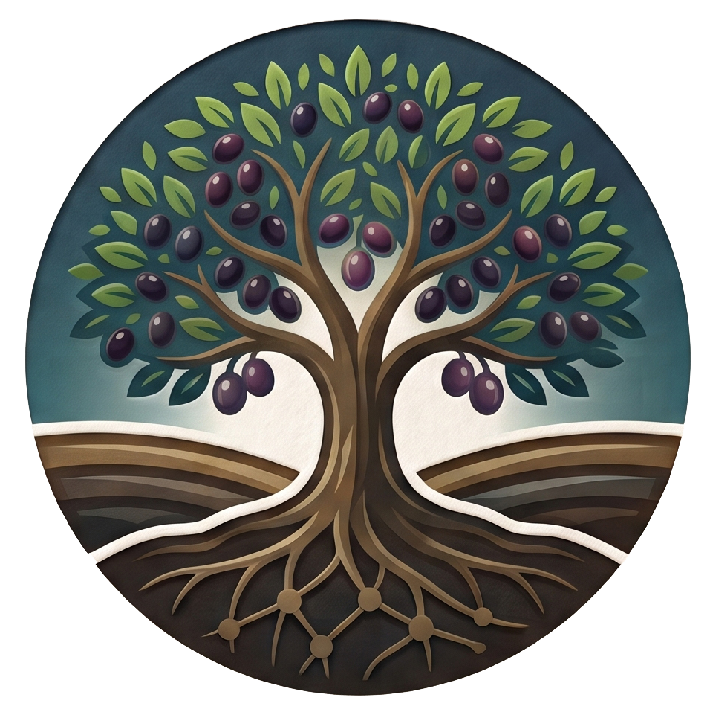
THEGOODGROUND.ORG
Matthew 13:23
LESSON FOUR: What is the Bible?
Week Three: What is the Bible?
Let’s start this week with a scripture! Why not? We’re talking about the Bible today!
Hebrews 4:12-13 (NIV) 12 For the word of God is alive and active. Sharper than any double-edged sword, it penetrates even to dividing soul and spirit, joints and marrow; it judges the thoughts and attitudes of the heart. 13 Nothing in all creation is hidden from God’s sight. Everything is uncovered and laid bare before the eyes of him to whom we must give account.
Alive and active - The Greek behind this is zōn kai energēs, living and energetic. The Word of God is not dead! It’s alive because the God who is still speaking this Word to us today is still alive.
Sharper than any double-edged sword – Penetrates and divides “soul and spirit,” “joints and marrow.” This illustrates how far the Word of God reaches down inside of you. It gets to the deepest parts of us, even the parts that are buried so deep that we don’t realize they are there until the Word of God exposes them.
Judges the thoughts and attitudes of the heart – This is your inner life, the part of us that we will try to hide. Your thoughts point to the way your mind reasons, and your attitude points to the things that motivate you to do the things that you do. The Word evaluates why you do what you do.
Nothing is hidden from God’s sight – Behind the Word is the person. Jesus is the living Word. Remember last week? He knew what the Pharisees were thinking before they ever spoke.
When we read God's Word, we think we’re reading the Bible, but the Bible is reading us. The Bible exposes what's inside us. It diagnoses. It cuts away what shouldn't be there. Then it heals the wound. That's why the Word is powerful. It exposes us to change us.
Welcome to Week Three! Today, we're going to answer the question: What is the Bible?
Before we do, let me ask, how many would agree that it’s very difficult to trust someone that you do not know?
Why is that?
It’s because our life experience has taught us that trust is earned, not given.
Blind trust in someone can be harmful to us and to the people that we love. Without knowing Him, trusting in God can be very difficult. Our life experiences can largely affect how we see God. Is He good? Does He really love me? Is He mad at me? Will He punish me for messing up? And so on and so on…
The Bible is the way that God has decided to make Himself known to us. It shows His character, His purpose, His love, and His plan.
Let’s be honest, at first glance, the Bible can feel overwhelming. It’s long. It doesn’t read like a normal book with a beginning, middle, and end. It comes in different translations. There are cultural and historical elements that don’t translate clearly from our cultural and world perspective.

The Bible was written…
- Over a span of about 1500 years.
- By over 40 authors from every walk of life, including kings, political and military leaders, a doctor, a rabbi, fishermen, tax collectors, poets, musicians, scholars, and shepherds.
- In different places, at different times, with different emotions.
- On three continents: Asia, Africa, and Europe.
- In three different languages: Hebrew, Aramaic, and Greek
- In a wide variety of literary styles: poetry, historical narrative, song, romance, biography, autobiography, law, prophecy, parable, and personal correspondence.
- The bible addresses hundreds of diverse topics with an amazing degree of harmony.
- Despite its diversity, the Bible presents a single unfolding story: God’s redemption of us.
(The New Evidence that Demands a Verdict by Josh McDowell)
This week, we are going to look at where the Bible came from, why we can trust it, how it shapes us when we read it, the influence it has had on the world, and, finally, what it looks like to actually apply it to your own life.

1. Biblical Authorship
One of the first questions people ask about the Bible is: Who wrote it? The answer is both human and divine, and understanding that is key to understanding everything else about it.

A. Written by People
Real people wrote the Bible. Like we mentioned before, kings and shepherds, fishermen and scholars, poets and prophets. Moses wrote the first five books. David wrote many of the Psalms. Paul wrote at least thirteen of the New Testament letters. Luke, a doctor, wrote one of the four Gospels and the book of Acts. John, a fisherman who became one of Jesus' closest followers, wrote a Gospel, three letters, and the book of Revelation.
All of the authors had different personalities, writing styles, and life experiences. And all of that comes through in the text. You can hear the urgency in Paul's letters, the suffering in Jeremiah's prayers, and the awe and wonder in John's descriptions of Jesus.

B. Breathed out by God
2 Timothy 3:16-17 (NIV) ¹⁶ All Scripture is God-breathed and is useful for teaching, rebuking, correcting and training in righteousness, ¹⁷ so that the servant of God^{[a]} may be thoroughly equipped for every good work.
The same breath that God used to bring life into Adam (Genesis 2:7) is the same breath that wrote the Bible. God worked through human writers, their experiences, emotions, and vocabularies to communicate exactly what He intended. This is what we mean when we say that the Bible is the "inspired” Word of God.
2 Peter 1:20-21 (NLT) ²⁰ Above all, you must realize that no prophecy in Scripture ever came from the prophet’s own understanding, ²¹ or from human initiative. No, those prophets were moved by the Holy Spirit, and they spoke from God.
C. One Story, Many Authors
We touched on this briefly before, but think again about what it took to produce this book.
More than forty authors. Over fifteen hundred years. Different cultures, different languages, different literary styles, poetry, history, law, prophecy, letters. The authors didn’t get together in a room to collaborate on writing all this.
From Genesis to Revelation, one story holds it all together: God creates the world. Creation is good. Then Adam and Eve broke their relationship with God through sin. And God spends the rest of the Bible pursuing us to restore what was lost. It all comes together in the life, death, and resurrection of Jesus Christ.
From the Old Testament to the New Testament, each book points back to Jesus.
Now someone might push back here and say, "Wait. Didn't a group of people actually decide what books went into the Bible?" And that's a good question.
The answer is yes, church councils in the late 300s formally recognized the canon of scripture that we have today. But here's what's important to understand: they weren't writing the books. They weren't editing them into agreement. They were receiving documents that had already been written and distributed for hundreds of years. They recognized that those documents already told one consistent story. The unity wasn't manufactured in a conference room. It was discovered. And that's what makes it so amazing.
(The Canon of Scripture - F.F. Bruce 1988)
**The Canon of Scripture refers to the collection of books officially recognized by the Church as divinely inspired, authoritative, and binding for faith and practice. ** The word "canon" comes from the Greek kanōn, meaning "rule" or "measuring rod," reflecting the idea that these books serve as the standard by which Christian belief is measured.

2. Biblical Trustworthiness
Believing that God inspired the Bible is a matter of faith. But faith is not the same as blind belief. This is important because many people assume that trusting the Bible means checking your brain at the door. It doesn't. There are real, historical, verifiable reasons to trust that the Bible we hold today is reliable. Let's walk through some of the most important ones.

A. The Manuscript Evidence
When it comes to ancient documents, scholars look at two things: how many copies survived, and how close those copies are to the originals. By both of those measures, the Bible is in a category by itself.
The New Testament alone is supported by over 5,800 Greek manuscripts, with thousands more in Latin, Coptic, Syriac, and other languages.
(By comparison, Homer's Iliad is one of the most carefully preserved works outside the bible. It survives in fewer than 2,000 manuscript copies, with the earliest copies dating to roughly 400 years after the original was written.)
Here's what makes the Bible even more impressive. The earliest fragment of the Gospel of John dates to within decades of its original writing. Compare that to Julius Caesar. We accept his writings as historically reliable, and our earliest copies come from over a thousand years after he wrote them—a thousand years. And no one questions Caesar.
Now, when we say "manuscripts," we're just talking about handwritten copies. Before the printing press and the Xerox machine, that's how every book was preserved. The more copies we have, and the closer they are in time to the original, the more confident we can be that what we're reading is accurate. And by that standard, the Bible has more going for it than anything else from the ancient world.
(Evidence That Demands a Verdict by Josh McDowell and Sean McDowell, 2017; The New Testament Documents: Are They Reliable? by F.F. Bruce, 1943)

B. Archaeological Confirmation
Here's something that happens over and over again. Critics say, "That person didn't exist. That city was made up. That event never happened." And then someone digs something out of the ground, and it turns out the Bible was right.
Cities like Jericho, Nineveh, and the Pool of Siloam were all questioned at one point. All of them have been excavated and confirmed. Some considered Pontius Pilate to be a legend until a stone inscription bearing his name and title was discovered in Caesarea Maritima in 1961. The Tel Dan Stele, discovered in 1993, contains the first reference to the "House of David" outside the Bible itself, confirming that Israel's greatest king was a real, historical person.
Now, archaeology doesn't prove every theological claim in the Bible. That's not what archaeology does. But it consistently confirms that the Bible's historical framework is rooted in real places, real people, and real events. And that matters, because if the Bible gets the history right, it's worth listening to when it talks about everything else.
(The Pilate Stone was discovered in 1961 at Caesarea Maritima by Italian archaeologists led by Dr. Antonio Frova. The Tel Dan Stele was discovered in 1993 by archaeologist Avraham Biran at Tel Dan in northern Israel. Both artifacts are housed at the Israel Museum in Jerusalem.)

C. Fulfilled Prophecy
This one is hard to explain away. The Old Testament contains hundreds of specific predictions about the coming Messiah. These weren't vague, general statements. They were detailed and written centuries before Jesus was born. And yet one by one, they were fulfilled in His life, death, and resurrection.
The Old Testament contains somewhere between 300 and 400 prophecies that we as Christians identify as pointing to the Messiah, depending on how you count them. The most conservative scholars work with a core set of around 48 that are specific enough and verifiable enough to stake a mathematical argument on.
Peter Stoner, a mathematician and professor who served as chairman of the mathematics and astronomy departments at Pasadena City College, took on this question in his book Science Speaks, which was reviewed and endorsed by the American Scientific Affiliation. He selected just 8 of the most specific messianic prophecies and calculated the probability of any single person fulfilling all 8 by chance.
His number was 1 in 10 to the 17th power. That is 1 in 100,000,000,000,000,000 or One Hundred Quadrillion. (One quadrillion is a thousand trillion)
To illustrate what that number actually means, Stoner used this picture. Cover the entire state of Texas two feet deep in silver dollars. Mark one of those silver dollars with a red X. Blindfold a man and tell him to walk anywhere he wants across the entire state and reach down and pick up one coin. The odds of him picking up the marked coin on the first try are 1 in 10 to the 17th power. That is the probability of one person fulfilling just 8 of the prophecies by accident.
Then Stoner expanded the calculation to 48 prophecies. The probability of one person fulfilling all 48 by chance is 1 in 10 to the 157th power. That number is so large it functionally has no illustration. The number of atoms in the entire observable universe is estimated at around 10 to the 80th power. The odds of one person accidentally fulfilling 48 specific prophecies exceed the total number of atoms in the universe by an almost incomprehensible margin.
Here are just a few of the prophecies:
- He would be born in Bethlehem (Micah 5:2, written 700 years before Jesus' birth)
- He would be born of a virgin (Isaiah 7:14)
- He would enter Jerusalem on a donkey (Zechariah 9:9)
- He would be betrayed for thirty pieces of silver (Zechariah 11:12-13)
- His hands and feet would be pierced (Psalm 22:16, written before crucifixion even existed as a method of execution)
- Soldiers would cast lots for His clothing (Psalm 22:18)
- He would rise from the dead (Psalm 16:10; Isaiah 53:10-11)
(Science Speaks by Peter Stoner, 1958; Evidence That Demands a Verdict by Josh McDowell and Sean McDowell, 2017)

D. The Testimony of Those Who Died for The Bible
The earliest followers of Jesus, the people who were actually there, the ones who would have known if the whole thing was made up, did not just believe it. They died for it.
Peter was crucified upside down. Paul was beheaded. James was thrown from the temple and beaten to death. These were not people dying for a philosophy or an idea they read about somewhere. They were dying for something they claimed to have personally seen with their own eyes.
People die for things they believe to be true. That is not unusual. But nobody goes to their death for something they know is a lie. If the resurrection was a fabrication, these men were the ones who made it up. They would have known. And when their life was on the line, and all they had to do was deny Christ, not one of them did.
That is not the behavior of people protecting a story. That is the behavior of people whose lives were changed by what they saw with their own eyes. They could not deny who Jesus was even if it cost them their lives.
1 Corinthians 15:3-6 (NIV) ³ For what I received I passed on to you as of first importance: that Christ died for our sins according to the Scriptures, ⁴ that he was buried, that he was raised on the third day according to the Scriptures, ⁵ and that he appeared to Cephas, and then to the Twelve. ⁶ After that, he appeared to more than five hundred of the brothers and sisters at the same time, most of whom are still living, though some have fallen asleep.
Paul is saying, ask the more than five hundred people who saw Jesus alive after His death!
(The Case for Christ by Lee Strobel, 1998; Evidence That Demands a Verdict by Josh McDowell and Sean McDowell, 2017)

3. Biblical Formation
Knowing the Bible is trustworthy is one thing. Letting it actually change you is another. Biblical formation is what happens when you do not just read the Bible for information, but allow it to shape your thinking, your character, and your heart.
2 Timothy 3:16 (NIV) ¹⁶ All Scripture is God-breathed and is useful for teaching, rebuking, correcting and training in righteousness,
Teaching: The Bible tells you what is true.
The Bible is the Word of God, which is the foundation for everything. It tells you who God is, who you are, what went wrong, and how it has been fixed. Without this foundation, your faith gets built on whatever you feel or whatever you hear, right or wrong. This is why the Bible is not optional for a believer.
Rebuking: The Bible shows you where you are wrong.
This is the uncomfortable one. The Bible does not just confirm what you already believe; it challenges it. It exposes pride, selfishness, and wrong thinking. A rebuke from God is not rejection; it is correction from a Father who loves you too much to let you keep going in the wrong direction. The kindness of the Lord leads us to repentance. (Romans 2:4)
Correcting: The Bible shows you how to get back on track.
Where rebuking says, "you are wrong," correcting points you back toward the right one. The Bible does not just diagnose the problem; it provides the solution.
Training in righteousness: The Bible builds lasting character.
If you are training your body, you can’t expect to go to the gym once and see any results. In the same way, you can’t just pick up the Bible once or twice and expect to see any change in your life. Strength comes with practice and consistency.

Here are a few simple principles for reading the Bible:
Pray and Read with Expectation.
Before you open the Bible, pray and ask God to speak to you through it. James 1:5 promises that God gives wisdom generously to those who ask. Come expecting something, and you will find it.
Read Slowly.
The goal is not to get through as many chapters as possible. Pick a passage, read it carefully, meditate on it, and ask: what does this tell me about God? What does this tell me about myself? Is there something here I need to obey? The Gospel of John is a great place to start, and a few thoughtful verses each day are worth more than racing through whole chapters without pausing.
Study the Bible Together.
Reading the Bible with other believers, in a group like this one, or with a friend, multiplies what you receive. Others will notice things you missed. Questions you thought were strange will turn out to be things everyone wonders about. You were not meant to figure this out alone.
Read and Obey.
James 1:22 (NIV) 22 Do not merely listen to the word, and so deceive yourselves. Do what it says.
Joshua 1:8 (NIV) Keep this Book of the Law always on your lips; meditate on it day and night, so that you may be careful to do everything written in it. Then you will be prosperous and successful.
God said this to Joshua before one of his most important assignments in Israel's history: leading an entire nation into the promised land. They were going to have to fight for it if they were going to possess it. God’s instruction was not to strategize more, fear less, or train harder. It was to stay in the Word, to meditate on it day and night. This produces the kind of person who can face whatever comes.
"Meditate" in the Biblical sense does not mean emptying your mind. It means to turn something over and over in your mind, like chewing on a piece of food until you have extracted everything from it. Biblical meditation is active, not passive.

4. Biblical Influence
Now, some people think of the Bible as a book only for Christians. However, the Bible has shaped the world we live in. The influence of the Bible on human civilization is vast and well-documented. Let’s discuss some of the other ways that the Bible has changed our world.

A. Education and literacy
For most of Western history, the reason people learned to read was so they could read the Bible. The first universities in Europe- Oxford, Cambridge, Harvard, Yale- every one of them was founded to train ministers and theologians. Harvard's original motto was Veritas Christo et Ecclesiae (E-klee-zi-I), which means "Truth for Christ and the Church." People believed that every person should be able to access the Word of God for themselves. And that conviction drove an entire civilization to become literate.
Then the Bible got translated into common languages. William Tyndale translated the New Testament into English in 1526. And they executed him for it. But before he died, he said his goal was to make it so that even a plowboy would know the Scriptures better than the clergy. Think about that. He gave his life so that ordinary people, people like you and me, could read the Bible in their own language.
The King James Bible came along in 1611, and it didn't just shape the church. It shaped the English language itself. Phrases you use every day, "the writing on the wall," "a thorn in the flesh," "the skin of my teeth," "a fly in the ointment," "the apple of his eye," every one of them comes straight out of the Bible.
B. Human Rights and Dignity
The idea that every human being has dignity and worth, the idea underneath every modern human rights framework, is biblical. Genesis 1:27 says that every person is made in the image of God. The Latin phrase is imago Dei. That's not a Greek idea. It's not a Roman idea. In the ancient world, it was radical. And it remains the strongest foundation anyone has ever come up with for arguing that every person, regardless of race, gender, class, or ability, deserves to be treated with dignity.
The abolitionist movement (the organized effort in the 1700’s to the 1800s to end slavery and the slave trade) in both Britain and America was driven overwhelmingly by Christians whose convictions came straight from Scripture. William Wilberforce spent decades in the British Parliament fighting to end the slave trade. And it was his Christian faith that kept him going. In America, Martin Luther King Jr.'s speeches drew directly from the prophets of Israel and the teachings of Jesus. The civil rights movement didn't just borrow biblical language. It was built on it.
C. Science and Medicine
A lot of people assume that Christianity and science have always been at odds. That's actually a modern myth, and it doesn't hold up historically. Most of the founders of modern science- Copernicus, Galileo, Kepler, Newton, Faraday, and Mendel- were devout Christians. They believed in a Creator, and that belief is exactly what led them to expect that the natural world would be orderly, understandable, and worth studying. They didn't see a conflict between faith and science. Their faith is what drove the science.
And the founding of hospitals and organized medical care for the sick were almost entirely a Christian advancement, motivated by the teaching of Jesus to love your neighbor and care for the poor.

D. Art, Music, and Literature
You can't study Western art, music, or literature without bumping into the Bible over and over again. Michelangelo's Sistine Chapel. Handel's Messiah. Bach signed every piece of music he wrote with the words Soli Deo Gloria, "To God alone be the glory." Dante's Divine Comedy. Milton's Paradise Lost. Tolkien. C.S. Lewis. Shakespeare's plays are full of biblical references. All of these people were drawing from the same well, the Bible.

5. Biblical Application – On Your Own
Everything we've covered this week- who wrote the Bible, why we can trust it, how it forms us, and the impact it has had on the world- all of it has been building to this. Because here's the real question: what do you actually do with it?
The Bible is not meant to sit on a shelf. It's not meant to be admired from a distance. It's meant to be lived. And this is the part no one can do for you. Your pastor can teach it. Your small group can discuss it. But the daily, moment-by-moment work of applying Scripture to your own life is between you and God. That's where the real change happens.

A. The SOAP method: a simple tool for daily reading
If you're new to reading the Bible on your own, here's one of the most practical tools you can use. It's a simple tool called SOAP. It stands for Scripture, Observation, Application, and Prayer. And it works like this:

Scripture: Write out the verse or passage you are reading.
There's something about writing Scripture by hand that slows you down and helps you remember it. Even a single verse is enough. You're not trying to cover a lot of ground. You're trying to go deep.

Observation: What does this passage actually say?
Before you try to apply it, make sure you understand it. What’s the context? Who's speaking? Who are they speaking to? What words stand out? Look for what's actually there, not what you assume is there.

Application: What does this mean for me, today?
This is where most Bible reading falls short. We read, we try to understand, and then we close the book and move on. The application step forces you to ask: is there a promise here I need to hold onto? A command I need to obey? A warning I need to take seriously? A truth about God that should change how I see my problem or my situation right now?
And be specific. "I should be more loving" is not an application. "I'm going to apologize to my coworker tomorrow the way Jesus describes in Matthew 5:23-24," that's an application.

Prayer: Respond to what you have read.
Close your time by talking to God about what you just read. Thank Him for what He showed you. Ask Him for help to obey. Confess where you've fallen short. The goal is not to finish a study session. The goal is to have a conversation.

B. Start Where You Are
You don't need a seminary degree to read the Bible. You don't need to understand every chapter before you can benefit from any of them. God meets you where you are. If you're brand new to this, the best thing you can do is start simple and stay consistent. Five minutes a day in the Gospel of John is better than a two-hour study session once a month that you never actually keep up with.
James 1:22-25 (NIV) Do not merely listen to the word, and so deceive yourselves. Do what it says. 23 Anyone who listens to the word but does not do what it says is like someone who looks at his face in a mirror 24 and, after looking at himself, goes away and immediately forgets what he looks like. 25 But whoever looks intently into the perfect law that gives freedom, and continues in it, not forgetting what they have heard, but doing it, they will be blessed in what they do.
Reading the Bible without applying it is like looking in a mirror, seeing exactly what needs to change, and then walking away as if you never looked. We've all done that. But James says the blessing comes to the people who look and then act. Not perfectly. Not all at once. But consistently, honestly, and with a willingness to let the Word do its work.

C. What the Bible is Not
As you build a relationship with the Bible, it helps to know a few things it isn't because it gets misrepresented a lot.

The Bible is not a magic book.
You can't just open it randomly, point to a verse, and expect it to give you a direct answer for every decision in your life. The Bible has to be read in context, understanding who wrote each section, to whom, and why. A verse pulled out of its context can be made to say almost anything. So read whole books, not just isolated verses.

The Bible is not a rulebook of do’s and don’ts.
At its core, the Bible is a story. It's the story of God's love for a broken world. Yes, there are laws and commands in it. But they exist within a relationship, not as a substitute for one. Jesus Himself said the entire Old Testament hangs on two things: love God and love your neighbor (Matthew 22:37-40). That's the frame. Everything else fits inside it.

The Bible is not a book you will ever fully exhaust.
People have studied it their entire lives and never stopped finding new things in it. The same passage you read at twenty will speak differently to you at forty, and again at sixty. It's alive, just as Hebrews 4:12 says. You'll never outgrow it. You'll only grow into it.
The Bible is not something you study to impress God. It's not homework for your faith. It's the voice of the One who loves you, speaking across thousands of years, in hundreds of different ways, and all of it pointing toward Jesus.
After the resurrection, two disciples were walking on the road to Emmaus, and Jesus walked with them. They didn't recognize Him at first. But later they said, "Were not our hearts burning within us while he talked with us on the road and opened the Scriptures to us?" (Luke 24:32).
That burning. That sense of recognition and wonder. It's available to you every single time you open this book. Not because the pages are magical. But because the Author is living.
I want you to remember one thing this week. The Bible was written for you.
Every word of it has been preserved for thousands of years so that you can hold it in your hands right now. That's not an accident.
Take it seriously. Read it slowly. Let it do what it was designed to do. And come back next week ready to share one thing from your reading that surprised you, challenged you, or changed the way you see something.
This Week's Challenge:
Try the SOAP method every day this week. Pick a short passage from the Gospel of John, even just a few verses at a time, and work through Scripture, Observation, Application, and Prayer. Keep it simple. Use a notebook or the notes app on your phone. By the end of the week, you'll have seven small entries that show you how the Bible is already speaking into your specific life.

Let's pray!

